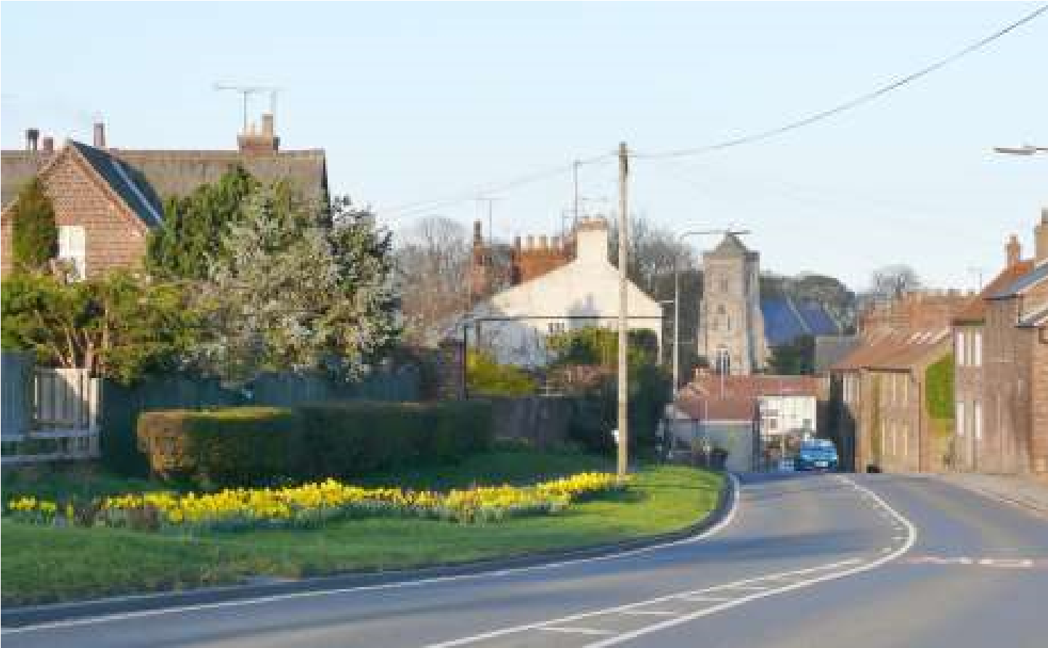

The Newsletter for Middleton on the Wolds

Issue No 14

April 2020

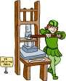
NEXT COPY DATE
14th April

Please send in your contributions to middletonflyer@yahoo.com. If I don’t acknowledge them please get in touch to make sure they have arrived.

As I am sure everyone is aware, all the usual events and get-togethers have been cancelled for the time-being. The planned quiz, Easter Fair and VE Day Event have also had to be postponed until further notice.

Let’s try to make the Messenger interesting to read while we can’t get out and about so much so please send me lots to fill up the pages ready for the May issue:

- Photos around the village
- Recipes
- Quizzes
- Poems
- Articles of interest

I have put a couple of Easter colouring pictures in the middle pages which may help to pass the time while we are indoors.

Lyn

4 The Paddocks 219500
ADVERTISING COSTS for the Messenger

Rates Month Year

Whole Page £25 £150

1/2 Page £15 £100
1/3 Page £10 £60

Full colour - Print run 500 copies

Contact: Tina 01377 217242, middletonflyer@yahoo.com

editorial
Strange days, indeed. Also worrying, frustrating and boring. Coronavirus, COVID 19, whatever you want to call it, is here and it’s serious. Now, some of you will have already put yourselves into quarantine; some of you may have no choice but to meet others because of, say, work; and some of you will just carry on life as normal because, let’s face it, the death rate is really
low so even if you do contract the virus you should get away with it. But what if you pass it on to someone who is less fit than you? Or older? Or who has already been made more vulnerable through an existing illness? Or who is just plain unlucky? These are the people we must look after and the best way to do that is for everybody to isolate themselves as much as possible and, if you have to go out, keep your distance from others and follow the hygiene advice issued by the authorities.
I’m writing this in the middle of March so by now the situation will have moved on and, hopefully, we will all have more of a handle on things. Even so, I think we should all prepare ourselves for a different way of life for the next year. And that doesn’t mean rushing off to Asda to strip the shelves. If you are one of those who is struggling to find pasta and toilet paper I know how you feel; if your cupboards are overflowing with enough to last you until this time next year I hope you feel ashamed of yourself.
Something more MOTW specific is the problem of safe driving on Station Road. On March 12th there was another instance of a vehicle running into cars parked near Kipling Court. Although having cars parked there does significantly reduce the width of the road in this area, I don’t think that’s the problem. I would suggest that it is people driving at an inappropriately high speed that are the cause of any accident. There is a 30MPH speed limit on Station Road, which is unclassified, and the problem is that some drivers haven’t got the common sense to foresee problems if they drive at speed on the wrong side of the road – on a blind corner. Add to that someone ‘still slowing down’ after their run from North Dalton and it’s a surprise these incidents/accidents don’t happen more often. But what to do about it? People who live on Station Road need somewhere to park and many don’t have offstreet parking, so the road is their best option. So how do we get through traffic to slow down? Maybe a chicane at the north end before the school would slow drivers coming into the village but, other than sleeping policemen, how do we slow down those who put their foot down as soon as they pass the take-away?
If you’re concerned you should start writing to our MP, to the Department of Transport and to East Riding of Yorkshire County Council. Send them photos to back up your arguments. It may take time, but this situation is made for direct action from residents. At the very least it will give you something to do while you’re self–isolating or maintaining your social distance.
I was just finishing this when I heard that pubs, restaurants and the like are having to close—fortunately I managed to break my fall by landing on Tjili! It seems to be getting ever worse, doesn’t it? On the other hand, you can still get out in the fresh air. Think of how much fitter your dog (and you!) will be with all the extra walks. And, as someone pointed out today, think of how tidy everyone’s garden is going to be by the end of summer. Maybe we could have an open garden day to celebrate when all this kerfuffle is over.
Having read through what I ‘ve written I hope you don’t think I’m taking this situation lightly because I think it’s the biggest crisis that this country, and the whole world, has faced since 1945. It has already fundamentally changed the way we live and how we interact with each other. Whether this is for better or worse we’ll have to wait and see.
In the meantime, spare a thought for all those who are still working. Not just in the health sector but also shop workers, teachers, transport and utilities workers and everyone who is doing their best to keep life as normal as possible for the rest of us.
I want to leave you with two thoughts:
 Is your true friend the one who comes to see you whatever the risk or the one who keeps you at arm’s length in case they might infect you?
And,
 It seems that nurses and bus drivers are more key to society than merchant bankers money brokers. Who knew?!
Before I go, I would just like to remind you that this editorial is my personal view. It has nothing to do with the Parish Council nor with anyone else involved with the Messenger. So, if you want to discuss or challenge any of the above, I’m the person to talk to.
Cheers,
Mike
If you have any ideas, comments or complaints (especially complaints) you want to share then send an email to middletonflyer@yahoo.com.
Remember, we can’t respond unless we receive your message.

A note from your vicar

Light in the darkness
Many of you may have seen in the press that for the first time since the Second World War the church is no longer holding public worship. However, the church is ‘not closed but changed’ - for the time being.
St Andrew’s Church in Bainton will remain open every day so you may visit at any time.
This year Sunday 22nd March is Mothering Sunday – for the church this is a time to think about ‘Mother Church’ and to remember the way she cares for us. We do also thank those who mother us and I always enjoy making the pretty posies of spring flowers to distribute during the service. Many years ago this was one of the few days on which, those who were in service, would be allowed to have the day off to visit their mothers and families – it always falls on the 4th Sunday in Lent. It was only really during the Second World War that the shift was made from Mother Church to our own mothers when the American soldiers stationed over here introduced the idea of giving gifts, flowers and cards as a ‘thank you’ to our mums. This years celebration was very different for many of us – unable to share the special day in the way we really wanted to.
The Church of England asked its congregations to mark this day by lighting a candle and placing it in our windows at 7pm as a sign of our hope that out of this darkness, light will come, and as an act of solidarity with all those around our world who are affected by and who are caring for, those afflicted by this disease.
I would like to extend this action. I shall do this each Sunday at 7pm until the darkness and fear has passed and we can join together once more. Maybe you would like to do the same?
If you have children, maybe they would like to make/ draw their own candle which they can put in the window each week. Or maybe you are creative and could do the same.
Though we are not allowed to hold public worship I will continue to say Holy Communion, on my own, at 10am each Thursday at Bainton Church and Morning Prayer around the 6 churches of our benefice. I will say prayers for our communities and our world. If you would like to join me from the safety of your own homes please do. If you do have any specific prayer requests please do let me know and I will include those.
This is one way Mother Church can support us all at this time. If you have any other ideas how the church can be of service please give me a ring or drop me an email.
I can be contacted on 01377 219471 or revjaney@talktalk.net
With kindest regards
Rev Jane
St Andrew’S church &
The wolds METHODIST CHURCH bainton
These churches are closed until further notice.

Messenger correspondence
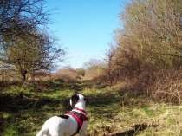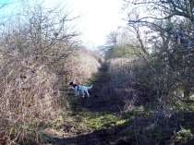

Hi Mike

Just a follow up on the path clearing. It's Done!

I was pleased to find after clearing the last of the "bramble
Tunnel" an almost bramble free path appeared, see
attached

photos)

Regards

Jim Wales

QUIZ PAGE
- What is the 6th planet from the sun in our solar system?
- Who was the first British monarch to broadcast a Christmas message to the nation?
- How many episodes of Fawlty Towers were made?
- What is the real name of Warren Beatty?
- What is the longest river in the UK?
- A ‘Sloppy Joe’ is an informal name for which item of clothing?
- Who wrote the 1873 novel ‘Around the World in Eighty Days’?
- Desperate Dan appears in which comic book?
- What colour are post (mail) boxes in Spain?
- How many Quires make up a Ream?
Quiz set by Rowland Wooldridge
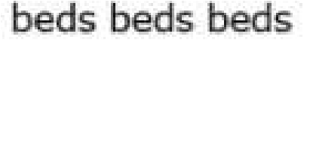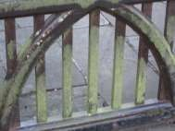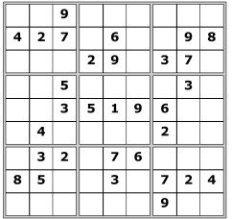

GARDENING DINGBATS

SUDOKU

WHERE IN MIDDLETON?

All answers on page 22

Photos by Ian Lavender

YCA Middleton-on-the-Wolds

Branch 2020 – 2021 Programme
We usually meet at 7.30pm on the 3rd Thursday of the month in The
Reading Rooms on Front Street. We have a different speaker or event each month – full details below.

STOP PRESS—DUE TO THE CORONAVIRUS-19
PANDEMICMEETINGS ARE CANCELLED UNTIL FURTHER
NOTICE— WE HOPE THAT ANY CANCELLED SPEAKERS WILL BE
INCLUDED IN OUR 2021/2 PROGRAMME

2020

April 16th Val Wise - Mary Wollstonecraft
Mary was an 18th Century feminist in favour of equal education for girls, female MPs and votes for women. She lived in Beverley for several years and had a short but fascinating life.

May 21st Claire Spooner—Millinery in Miniature
Claire is a bespoke milliner who specialises in elegant headwear for all occasions and hats for theatrical productions. In this talk she takes a fascinating look at changing millinery fashions from the 1850s onwards. Claire shares with you her collection of period antique and vintage hats, along with reproduction pieces she has made, period trimmings and tools.

Open to non-members £5

June 18th
Stephen Wells—The Magic Circle and the Great Magicians. The story of The Magic Circle. A fully illustrated talk demonstrating some of the classic magic of famous names like Paul Daniels, David Nixon, Derren Browne, Dynamo and other magical greats. This combines a fascinating talk with some superb magic performed live.

25th JULY -- VILLAGE SHOW Please support

August 20th Alan Lavender MBE—Chef to Four Prime Ministers
Alan was Chef at Chequers, the Prime Minister’s country house. He worked there from the time of Margaret Thatcher until his retirement when Gordon Brown left.

September 10th Paul Schofield—A guided walk around the Beverley Town Trail
This additional event will be early evening, with the option of supper at The Monks' Walk afterwards. £5.00 or £10.50 including supper to be paid in advance.

September 17th Chris Powell—From Trash to Treasure
The Cone Exchange is Harrogate’s unique community scrap store and home to Captain Rummage, also known as Chris Powell. Every year the Cone Exchange works with 200 Yorkshire schools, community groups, social enterprises and charities to transform trash into treasure and encourage young people to become environmentally aware whilst also providing a valuable resource for crafters from the local area. The Cone Exchange is the flagship community project of Bettys & Taylors of Harrogate.

October 15th
Richard Baines—From Goshawks to Humpbacks; Wildlife of the North York Moors National Park.
An illustrated talk with high quality images focusing on the wide diversity of wildlife from orchids, through birds of prey to whales found in this beautiful National Park. An insight into the ecology and top tips of where to go and what to find

November 19th Helen Costello – Xmas Wreaths & Floral Arrangements
Helen Costello of Purple Heather Floristry will demonstrate how to make flower wreaths and arrangements for Xmas'. Christmas wreath starter kits available to purchase on the night for £5.

December 7th Xmas Dinner at ‘The Robin Hood’

2021
January 21st - Party Night

February 18th
Seeds, Trees & Leaves Indian Woodblock Printing Workshop Discover the art of printing with woodblocks carved in India.
Create a printed tea towel or tote bag for £6; or a set of 5 cards for £3. All materials included.

March 18th Marion Gamble—The work of The Yorkshire Air Ambulance

New members are always welcome
Subscription for 2020/21 is £25

For further information contact:

Christine Johnson 01377 217374

Middleton on the wolds ce ve school
Executive Headteacher: Mrs E Harros
Station Road, Middleton on the Wolds, Driffield YO25 9UQ
E-mail:middleton.primary@eastriding.gov.uk Tel: 01377 217323

London Residential
On Friday 7th & Saturday 8th February, 12 members of staff/adult helpers took a group of 52 children from Middleton on the Wolds, Beswick & Watton and Bishop Wilton schools to London. After boarding the train from Hull to London Kings Cross, pupils sampled some British tourism such as a river cruise along the Thames, a visit to 10 Downing street and a tour of the Houses of Parliament. A short tube ride later and we arrived at the Natural History Museum. As if the children and staff weren’t tired enough, there were more activities and an animal show before a torchlight tour finding clues before sleeping in the great hall! The next morning, we all enjoyed another animal show and a tour of the museum before it opened to the general public. A very tired group of children and staff arrived back at Hull station early Saturday evening.
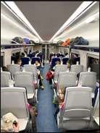

Clothing Collection
Our next clothing collection will be on Wednesday 10th June. Any unwanted clothes, coats, shoes, hats, scarves, handbag, belts, household linen, towels, curtains and soft toys can go in the collection. The heavier the collection, the more money that is raised for school, so please save all unwanted items for us. All bags need to be at in the school car park by 9:00am on the morning of Wednesday 10th June. Thank you.

Middleton Minis
Our parent, carer, baby and toddler group runs from 1:30 to 3:30pm every Tuesday afternoon (term time only) at Middleton on the Wolds primary school. Drop in for 20 minutes or the full 2 hours. We look forward to seeing you.

On-going Collections
On-going Collections – We collect used stamps, batteries, printer cartridges and mobile phones. Thank you.

Middleton on the Wolds Nursery
At Middleton on the Wolds CE (VC) Primary School Providing education for 2, 3 and 4 year olds Monday - Friday.
We accept the Government’s childcare vouchers for up to 30 hours of free provision for 3 year olds (conditions apply)
Additional sessions can be purchased for £13.50 per session for 3 year olds and £15.75 for 2 year olds.
Lunchtime sessions are £1.75 (free if children attend for the whole day) with the option to purchase a school meal for £2.40.
Children are welcome in the term after their 3rd birthday for funded places.

For further details, please contact: Heather Measom or Sharon Stone
Email: middleton.primary@eastriding.gov.uk
Tel: 01377 217323
Colouring pages for the young ….
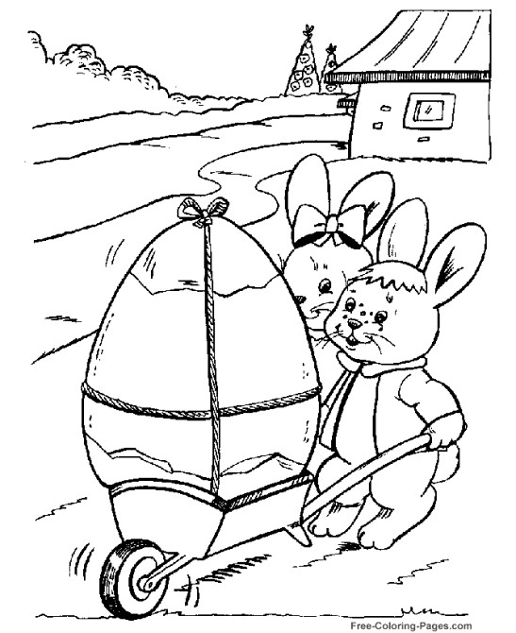
….and not so young

Middleton book group
March Books

The Garden of Lost and Found by Harriet Evans.

This covers four generations who lived in Nightingale House from 1919 to the present day following their happiness and sufferings. The story of their lives keeps you gripped to the very end and the characters stay with you. — a good read!

The Librarian by Salley Vickers

A story about a young children’s librarian working in a small market town in the midlands. We learn how the library alters children’s lives as Sylvia encourages the children to find as much pleasure from reading as she did when a child. The book group enjoyed the references to various children’s books that they remembered. Salley Vickers is an excellent writer and all her books are very different.

JHA

Next books for discussion:
April “The Man Who Didn’t Call” by Rosie Walsh
“A Noise Downstairs” by Linwood Barclay

Of course we will not be able to meet to discuss the books (or partake of the tea, cake and chat) for a while but reading will be a good way to pass the extra time that many of us will find that we have indoors. We can still pass our comments on via email. In fact, if anyone has any comment on any of the books that we mention we would be pleased to hear from you at the email below.

If you are interested in finding out more about the Book Group contact Lyn Dennis 219500 lyndennis456@gmail.com

Parish council news
As you read this month’s edition of the Middleton Messenger life in the village will be very different with many people working from home, not having any work or possibly having to self-isolate. Hopefully the measures that have been introduced by the government along with our co-operation; means as a country we can beat this Coronavirus – Covid-19.
Middleton is a great village and we have many caring residents who are offering to assist others, who need help shopping, collecting medication etc.; if they are unable to travel to the shops or have general difficulties coping. This kind of help could be greatly needed and if anyone is able to assist their neighbours without putting themselves at risk I am sure it would be greatly appreciated. Such generous and courageous offers of help have to be admired and show many people in Middleton care about their village and the people of Middleton.
A letter drop was delivered by various people offering to help and others have offered help through various Facebook pages. Should you need directing to any of these kind people please do not hesitate to contact a member of your Parish Council.
The Authorities have advised the Parish Council that this responsibility should not fall on Middleton Parish Council, and should be left to the Local Authority. However human nature makes us all want to help where ever we can, and I am sure on a personal level we will endeavour to help along with others.

PLEASE NOTE
As a result of the Coronavirus outbreak we have also been advised that all future Parish Council Meetings should be cancelled until further notice.
The Parish Council is still functioning through the clerk, in consultation with the chair. The Clerks contact details are: 01262 470496, or by e-mail pc@middletononthewolds.co.uk

OTHER NEWS
Sadly we are still experiencing problems with speeding traffic through Middleton on all our roads; and we had a resident complaining about speeding traffic along Beverley Road from the junction of the B1426 into the village. Please respect people live in the houses and cottages along this stretch of road, and there is no footpath leading to these properties which was also discussed as a concern.
We have had another accident recently on Station Road. It is a great concern of the Parish Council and we are consulting with the East Riding of Yorkshire Council Highways Department and other departments and being assisted by our Ward Councillor Cllr Kevin Beaumont. Unfortunately the accident was partly caused by parked vehicles on the road. We appreciate many residents in Middleton have difficulties parking and have to park on the highways; we acknowledge parking is permitted throughout the village; however please give consideration to where you park to avoid; obstructions to oncoming traffic, blocking sightlines from other road junctions, private drives, cul-de-sac’s etc. Parking is an issue all over the village and we have had complaints about Greenfield Road, South Street, Station Road, and The Paddocks. Good parking can help avoid accidents; so please do your bit and help avoid accidents which could result in serious injuries or fatalities.
The tree felling along the railway embankment has now been completed and generally most people seem to appreciate the work was needed to safeguard residents in their gardens on Greenfield Road.
Finally on behalf of Middleton Parish I wish you and your family’s strength and love to thrive through the challenges ahead.
John Eastwood
On behalf of
Middleton Parish Council

Work is now well underway within East Riding of Yorkshire Council to determine how we can together best support our vulnerable residents during this challenging time as we all respond to the COVID-19 pandemic. We are treating this matter as one of our highest priorities. We are going to tackle this by working alongside the HEY Smile Foundation, a charity which works closely with the private, public and voluntary sectors. Plans are in place to set up a contact centre which will take calls and receive emails from vulnerable or at risk residents who most need our help and who cannot source that help from friends, family or others. This will be in place by the middle of week commencing 23 March. This centre will receive and record the requests for help and will triage those requests and source the best solution.

For the latest government information on Covid 19 use the following website
www.gov.uk

CORONAVIRUS

Looking after the Vulnerable and Elderly

Residents are aware that Middleton is a very caring Village. During the present crisis we should be very aware that neighbours may need a great deal more help. Very few if any don't have family/relatives who are near enough to look out for them and the following suggestions may be of assistance.

YOU DO NOT HAVE TO VISIT THEM

1 A twice daily telephone call (if possible) especially to those who live alone could be a life line, not only because of the present situation but also people can get depressed if isolated. Even carers need to know others care about them.

2 MEDICATION
Those who use the Cranwell Road Surgery can have this brought back to the Post Office on a Thursday for collection. Helpers could collect for them and leave at their doors. For other surgeries please contact them to make suitable arrangements.

3 HEATING
Ask if they need assistance with this. Getting Coal if necessary and leaving at door outside etc.

4 FOOD
Do they need any fresh items such as Milk again you can make arrangements to leave outside.

5 Ask if they have a Key Holder or Lifeline in case of any Emergency and get their telephone number.

Local Birds & wildlife
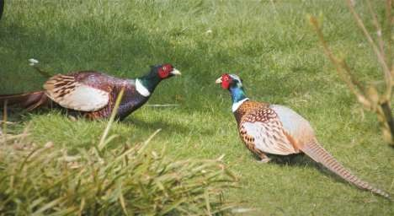

It is ironic that just as all the birds in our gardens are getting more sociable - albeit in a “I want sex!” way (it being Spring) us humans are being forced to step back from each other and cancel all our get-togethers in the village.
In our gardens the birds are all dressed in their finest and brightest feathers, fluttering and dancing and chasing each other. We will have to do with fraught shopping trips (for those of us allowed out) and gazing glumly out of our windows.
OR… It is an opportunity for people to take more notice of their garden visitors. Children (who are going to take a LOT of entertaining if this situation drags on) do enjoy learning to identify birds – and correct their less-savvy parents – and some older ones might like to keep a record of which birds, and how many, they see from week to week. The RSPB have lots of info on their website, and the BTO (British Trust for Ornithology) keep records of sightings, though you have to join and then pay to have your records kept by them.
I would be interested to get your records of numbers of birds seen together at any one time – we’re at about 15 chaffinches at the moment for example. How big are your groups of long-tailed tits? How many wood pigeons can one garden support (Relatives living in West Yorkshire have been known to comment “These are the fattest pigeons I have ever seen!” (Typed with a big sigh).

Anyway, spring is under way, the Middleton Embankment has been cleared (reserving judgement on this until later in the year), hares are beginning to chase each other and garden feeders are busy. Male pheasants are going head -to-head and the dawn is getting earlier, with the dawn chorus ready to erupt any time now.
Please send me your comments, viewings, records and photos!
Keep safe, Barbara lavenderbarbara97@gmail.com or phone/text 0777 192 7868

POLLINATION
In these difficult times it’s hard to put a positive spin on the effects of the current state of affairs but one thing is it is certainly giving us is more time at home and in the garden. Let’s use this time to try and make your garden what you want it to be. I for one want to try and help nature thrive and encourage wildlife. The best way to do this is plant for pollinators and insects, build bug hotels and leave an area of your garden to go wild.
Why should we save insects?
Butterflies, moths and bumblebees are an essential part of our eco-system. They are an important element of the food chain and are prey for birds, bats and other insectivorous animals. We must act now to help them rest, recuperate and rejuvenate in our own gardens.
Pollinating insects such as bumblebees and butterflies are in decline across the UK. These
insects are homeless and hungry. Their homes are disappearing and their populations are plummeting. They are running out of places to go, but you can help.
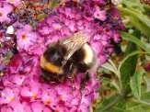
According to a recent survey, 84% of UK adults are concerned about damage to the natural environment, and 56% about local biodiversity. Many are keen to take action to tackle these problems but need advice on which plants to grow in their own gardens to support our native biodiversity.
The good news is that this advice is now freely available and easily accessible in a handy, downloadable plant guide with information about how best to help butterflies, moths, and bumblebees across the UK.
https://butterfly-conservation.org/insectae
The Bumblebee Conservation Trust has joined forces with Butterfly Conservation and Channel 5’s Dr Amir Khan in a joint campaign to encourage people to become Nature Doctors in their own gardens by creating their own Insect A&E!
Dr Khan said “As a nature lover, I am delighted to join with these brilliant organisations in asking people to act now for wildlife. Simply by choosing some of these plants, people’s gardens can become a haven for pollinators".
If people make small changes to their gardens they can achieve a massive change for nature. So, join in today and become a Nature Doctor!
If you need help on how to do even more try the Wildlife Trust’s advice here:
https://www.ywt.org.uk/actions
There you can find plans on how to build a bird box or just how to manage your garden for wildlife.
All the advice is free and all of it will help save millions of tiny lives.
Do something positive with your time and make a difference.
Sent in by John Fisher

Quiz answers

Where in Middleton:

The School
-

new
block

The Cemetery

Dingbats:

Weeding

Scented rose

Spiny cactus

Potter around the
garden

Raised beds

1

Saturn.

2

George the Fifth (in 1932)

3

12

4

Warren Beatty

5

River Seven

6

Jumper/sweater

7

Jules Verne

8

Dandy

9

Yellow

10

20
]
[500 sheets

LOCAL HISTORY
THE WAR PROGRESSES
The only way of inflicting damage on the German homeland until late in the war was by air power. At the time of the enemy attack on Driffield airfield in 1940 work had started on a new base at Pocklington which was to remain operational throughout the war and contribute to the ever increasing strikes against the Axis power. It now forms part of the gliding club.
Tom Soanes’s diary contains various references to air activities:- 11th February 1943 - Aircraft crashed at North Dalton.
3rd November 1943 - Aircraft crashed near Moneypot.
3rd March 1945 - Jerry planes over.
In Spring 1943 Army Northern Command instructed the Wolds farmers that livestock had to be removed from land north of the Market Weighton – Driffield Road to allow training for what would become known as D-Day with the area being handed back for farming in September 1944. The terrain was considered similar to Normandy where the invasion of Europe was to start and maps of the Wolds were produced in the French style to enable troops to familiarize themselves with the ones they would use on reaching the continent. However the field hedges in the Wolds, which were thought to resemble the French “bocage,” were in fact lower than the French variety which gave the enemy tank a distinct advantage when battle took place in France. Despite this discrepancy Cliff Pratt, a lifelong touring cyclist, recalled the dangers of visiting the Wolds when he stated “tanks were liable to burst suddenly through the hedge, cross the road and disappear through the hedge opposite. One had to watch the hedgeside even more than the road.”
One night Jack Bentley and his friends were returning by bus from Pocklington to Huggate only to be stopped in Warter to make way for a long military convoy and told to continue on foot away from the road which they did by “legging it” over fields to Huggate.
The training area had important visitors, Churchill, the American General George Marshall, who later gave his name to the postwar rescue plan for war devastated European countries and King George the sixth with the then Princess Elizabeth all came. When the invasion force finally moved south, no doubt with a feeling of great trepidation which would be difficult to describe, Tom Soanes, who had volunteered for the Seaborne Observers, also went to the south coast for training At the coast the unseasonable weather was appalling which made the task of General Eisenhower in deciding to launch the invasion feel like the greatest burden in the world. The decision was made and on Tuesday the sixth of June 1944 began the largest seaborne invasion in history.
It is interesting to note that as the invasion force advanced through Normandy one of the towns badly damaged in the vicious fighting was Mortain the name place of Robert, Count of Mortain, King William the Conqueror’s half brother who for a brief time after the Norman conquest owned some land in Middleton.
In Middleton the school was under pressure during the war with one hundred evacuees from Sunderland Redby school using it in the afternoon and the village hall in the morning while Middleton children had the school in the morning and the village hall in the afternoon. In April 1940 the schools amalgamated for the rest of the war.
There were distractions from the war one being the iconic radio programme “ITMA” with its team of comic actors led by Tommy Handley making light of wartime characters and situations. After the war it emerged that Hitler’s interpreter, who was allowed to listen to foreign broadcasts, found it funny. Tom Soanes who enjoyed good entertainments saw a stage version of it in Hull. On a more serious note that year there was a talk in the village on modern poets and Mr Hogarth, school headmaster succeeded Miss Moate as honorary village librarian.
In October 1943 the Middleton Girls’ club under Miss Helen Clark were shown around the Hull Guildhall by the Lady Mayoress Mrs. Schultz (wife of the man destined to become the dominant figure in local politics in postwar Hull). They visited St Mary’s church Lowgate and finished off at the New Theatre to see the Agatha Christie play now known as “Ten Little Indians.”

Geoff Wisher To be concluded

Advertisement
Advertisement
Advertisement

LOCAL CONTACTS Bell Ringing Chris Atkin |  | 217285
Book Group/Middleton Movers | Lyn Dennis | 219500
Bowls Club | Rob Bradley | 217435
Country Women’s Association | Christine Johnson | 217374
First Responders | Chris Brent | 219469
Line Dancing | Pat Pottage | 217516
Methodist Chapel | Miss P Hodgson | 217426
Middleton Messenger | Mike Kelly | 07713 620912
 | Lyn Dennis | 219500
Middleton Womblers | Andrew Naylor | 219072
Parish Clerk | Sandra Morrison | 01262 470496
Reading Rooms | Kath Bentley | 217456
Recreation Club | Dave Newlove | 07901 833784
St Andrew’s Church | Rev Jane Anderson | 219471
St Andrew’s Church Warden | Roger Lowe | 217656
Table Tennis | Louise Newlove | 217801
Village Hall | Lyn Dennis | 219500
Village History Geoff Wisher |  | 217517

